CITY OF STATHAM
AGENDA
Statham Community Center
336 Jefferson Street, Statham, GA 30666

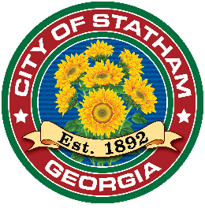
WORK SESSION – March 5, 2024 6:30 P.M.
CALL TO ORDER
Roll Call
INVOCATION AND PLEDGE
WORK SESSION
MINUTE APPROVAL
- February 20, 2024 Regular Meeting Minutes
REPORTS
- Finance Department
- Police Department
- Public Works Department
- Mayoral Report

PUBLIC HEARING

- R-23-04 Rezoning (Tabled from the January 30, 2024 Regular Meeting): PLG, LLC, c/o Anderson, Tate and Carr, by Melody A. Glouton, applicant, ARJAC Enterprises, Inc., property owner, seeks rezoning from RR, Rural Residential District and SR-2, Suburban Residential District to PUD, Planned Unit Development of 69.59 acres (Map/Parcels ST04/058, 25.074 acres; ST04/059, 26.046 acres; and part of ST04/095B, 18.470 acres) fronting on the north and west side of Jefferson Street across from and north of Bear Creek Middle School. Proposed use: Single-family detached subdivision (123 homes/lots).

DISCUSSION ITEMS

- O-24-02 Ordinance Amending the FY23 Budget: First reading. To approve an FY23 Budget Amendment Ordinance; to maintain a balanced budget by department per Georgia law, the City is required to amend the following department budgets and their respectful line items to maintain a balanced department.
- Fiscal Year 2023 Audit Acceptance

CITIZEN INPUT

ADJOURN

